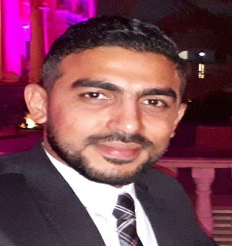
Curriculum Vitae
Mohamed Abdel-Aziz Saied Ahmed

Bio- Data
- Date of birth: 21/10/1988
- Nationality: Egyptian.
- Status: Married.

Personal Information

Address: 100m Mubark Housing – El-shrouk City –Egypt
Phone: 02- 26069675(Home) Mobile: 01102568592 (Cell)
E-Mail: mabdelaziz424@yahoo.com
Objective / Skills

- Ability to learn quickly & adapt easily to new environment.
- Self motivated creative with practical approach to problem solving.
- Excellent communication skills.
- Ability to work in a team
- Ability to work under pressure
- The ability to lead a team to work

Education

  - Graduated from: Ain Shams University- Faculty of Arts
  - Specialization: Ancient European civilization

Experiences

- Worked at: Helio Park Hotel as a Front Office
Green Hills Club as Public Relations
Green Hills Club as Sales and Marketing Officer
Green Hills Club as Sales and Marketing Manager
- Working: at Barcleys Bank as Sales representative ( outdoor )
from December 2014 : Feb. 2015
- Working : at OFOK Real Estate as Sales representative
From Mars 2015 : Mars 2017
- Working : at OFOK Real Estate as Sales team leader
From Mars 2017 : July 2021
Working : at Taj Misr Development as Senior property consultant
From August 2021 till now

Language

- Arabic: native
- English: Good command of both writing and speaking

Computer
- User of, Microsoft office, & internet facilities...
- Driving license & I have a car

